1. **We will see** 
   1. What is Cucumber?
   2. What is Selenium?
   3. What is BDD?
   4. How do Selenium & Cucumber work together?
2. We will see some basics in this lecture in order to set the stage to how to proceed in this course.
3. To understand Cucumber, you need to understand **BDD**.
4. **What is BDD?**
   1. BDD stands for **B**ehavior-**D**riven-**D**evelopment.
   2. So, BDD is development approach.   
      It may be Web page, Mobile App, or a Backend DB etc.  
      So, before developing anything, you need **to define** **explicitly** what you are going to develop and we need to communicate that content which is very important. So that is where BDD comes into picture. Therefore BDD involves usage of one common language that enhances communication b/w tech people and non-tech people.  
      So, when developing a product, there will be one developer and one BA or PO (Product Owner) who will define the scenarios what to develop.  
      So, everyone should understand what they are doing.   
      Developers may be their own terminology to describe the requirements and PO may have his own terminology to create the requirements.  
      So, in order to avoid any conflicts, they both **must have a common language or one common format** to understand and create the requirement.  
      That is why we say here 🡺 Behavioral Driven Development.  
      The following is one of BDD approach of defining a requirement or defining a test case.  
      
      1. **Given**: I am at landing page of Ecommerce application.
         1. This is a **precondition** that the user is already on landing page.
      2. **When**: I searched for product which doesn’t exist.
         1. The **action** the user performs.
      3. **Then**: No results message should be displayed.
         1. The **Outcome** when the above action is performed.
   3. This way we define requirements or test cases. The development and testing will be done based on the requirements/test cases defined like this.
   4. This way there will be common documents for Developers to develop product and Testers to test the product.
   5. This is very short introduction but in later lectures we will see BDD in details and from the scratch.
5. **What is Cucumber?**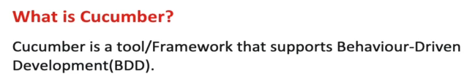
   1. Cucumber is a tool or a framework that supports this BDD process.
   2. That means Cucumber will give you an environment to define all these BDD scenarios.
   3. You might think what is environment here?
   4. We can define (Given, When, Then) in a text file but BDD is not about writing just (Given, When, Then). It is more than this.
      1. You can parameterize (Given, When, Then).
      2. 
   5. Mostly, people use Cucumber for **Automation**.
   6. Why?
      1. (Given, When, Then) is requirement as well as test case.
      2. It is a test case for QA to write **automation test**.  
         Text

         Description automatically generated
      3. So, QA can write some code where a user can automatically open the browser and go to this website URL (for Given Part).
      4. For “When” part, QA can tie up some code to perform search action.
      5. For “Then” part, QA can tie up a code to say that verify if no results are displayed.
   7. Now the question is if you write code somewhere, how that code is tied up with the “Given, When, Then”.
   8. Let me show you one simple example of Cucumber.
      1. A picture containing scatter chart

         Description automatically generated
      2. 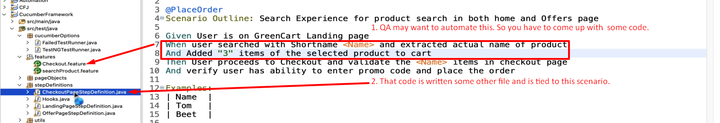  
         Let’s see the code but don’t worry we will see in detail later on.
      3. Graphical user interface, text, application, email

         Description automatically generated
      4. So, Cucumber gives all necessary Framework features for **Test Automation Execution**.  
         But remember Cucumber doesn’t automate web browser. You can use Cucumber for any automation tool.
      5. Some BDD test case, you can write for you mobile like  
         **Given:** I landed on mobile app’s landing page.  
         For Mobile, you can use **APM Automation Tool**.  
         For Web, you can use **Selenium Automation Tool**.  
           
         For DB BDD test case/requirement, you can write like this:  
         **Given**: I have a DB Connection.  
         **When**: I fire a query to search the product.   
         **Then**: DB results are not displayed.   
           
         So, Cucumber doesn’t care which Automation tool you use.   
         It gives you just a stable executable automation with a lot of framework features.
6. BDD style is common language for all like BA, PO, Developer, QA.
7. Cucumber can be created in different languages like Java, Ruby (originally written in Ruby), Python.
8. 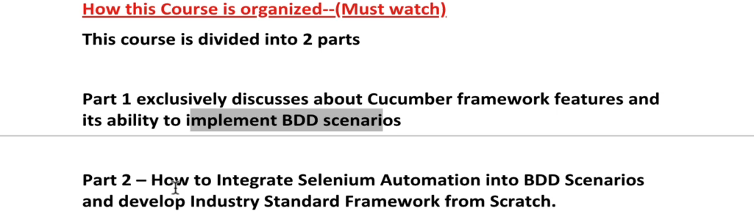  
   Part 1 is important to be covered to understand Part 2 and our target is Part 2. 😊